

**Placement Empowerment Program**

***Cloud Computing and DevOps Centre***

# POC 3: SET UP A LOCAL GIT REPOSITORY

Name: Manashaa U Department:CSE



# Introduction

By creation a local git repository, each developer gets their own local repository, complete with a full history of commits. Having a full local history makes Git fast, since it means you don't need a network connection to create commits, inspect previous versions of a file, or perform diffs between commits

# Step-by-Step Overview

## Step 1

Check if your system has git installed else Download git your sytem

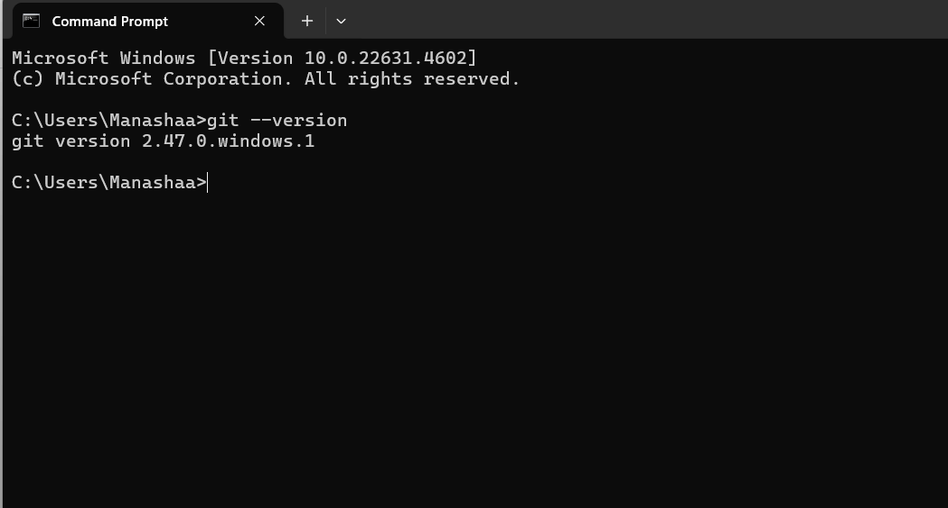

## Step 2

Open github and create a new repo by clicking “new” in the left

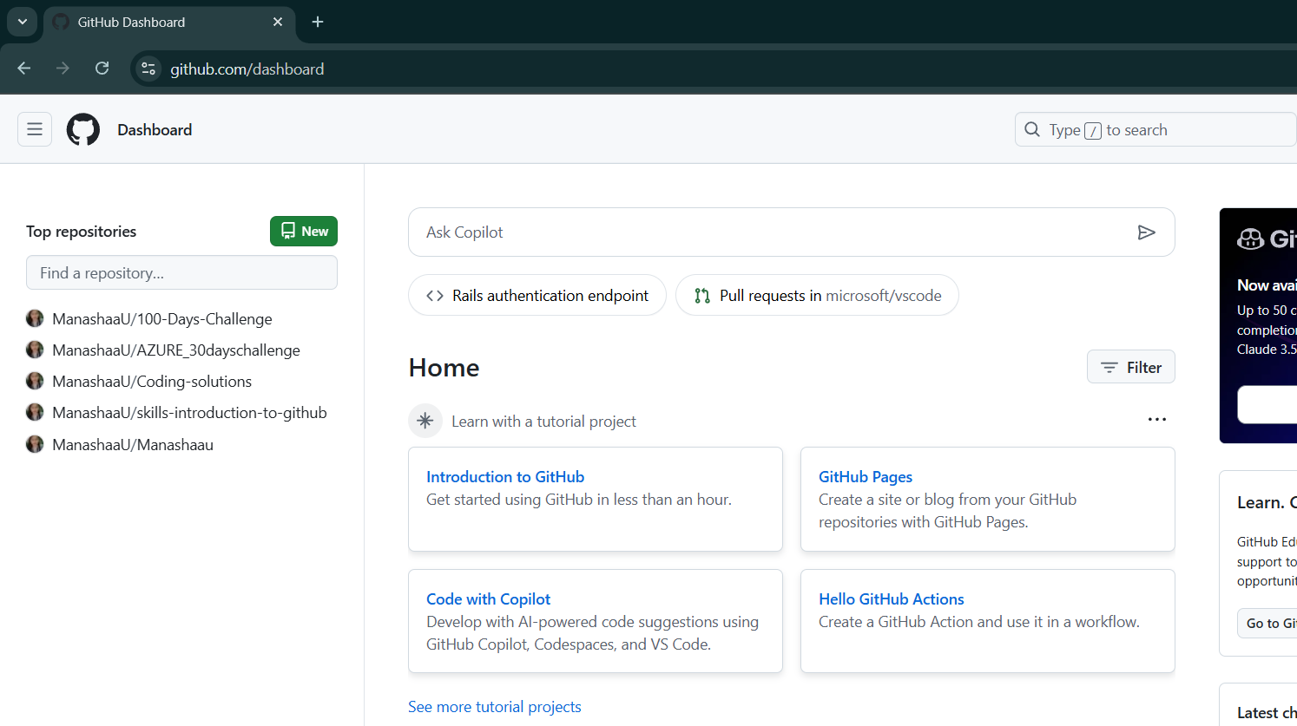

## Step 3 :

Create a new folder



## Step 4

Copy the file detail

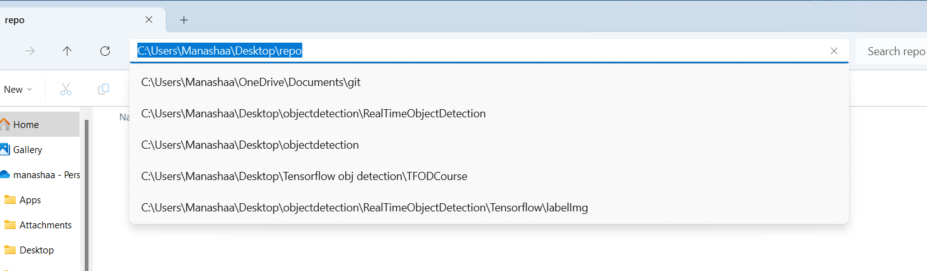

## Step 5

In the command prompt , used the command “ git - -init” and past the file location for the repo to clone

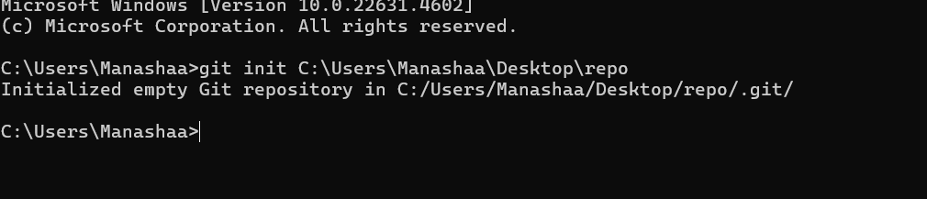

## Step 6

You can see the file will have the read me file from the new reop created in github. Thus, creating a local repository.

# Outcome

A local repository is a copy of the entire project's history and codebase that resides on a developer's machine. When a developer initializes a local repository, Git sets up the necessary infrastructure to track changes, branches, and commits within the project .We can create a local repository by the following commands